AIPP LAB 11
Name: SYEDA FARHATH UMAMA
Hall Ticket No.: 2503B05143
___________________________________________________
Completed this Assignment using VS CODE Al Integration.
Task 1:
Ask AI to implement a stack class with push(), pop(), peek() and
is_empty() methods.
CODE:
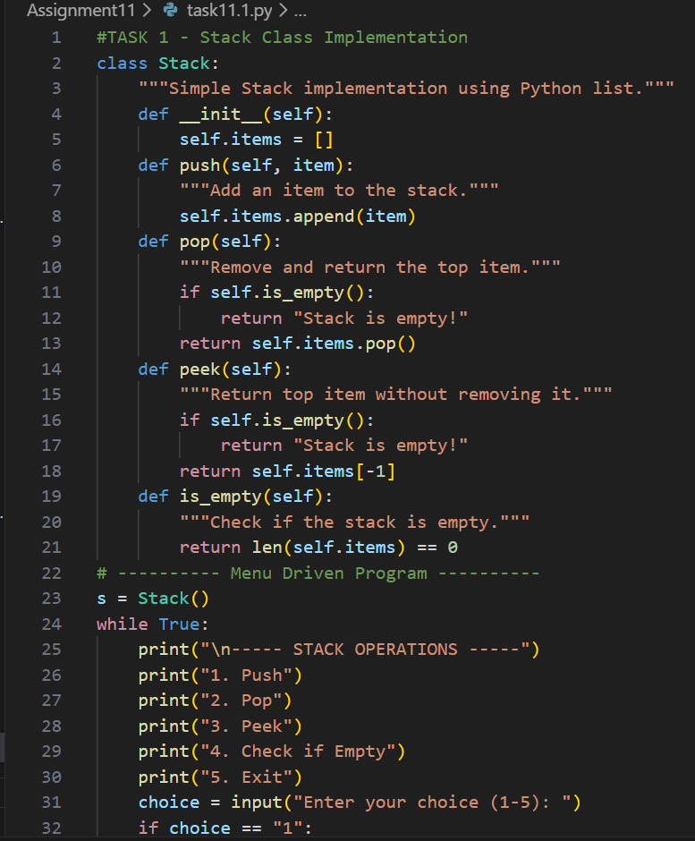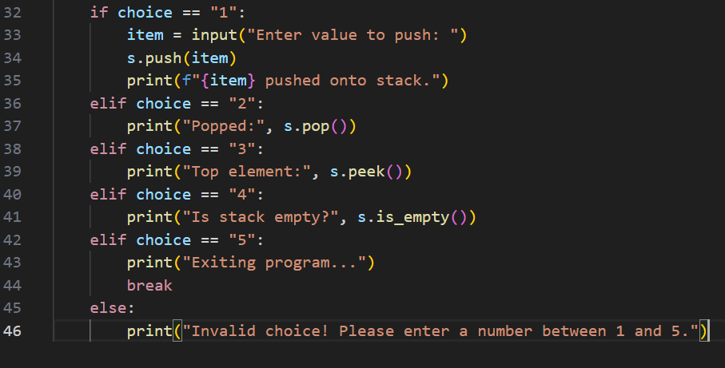

OUTPUT:
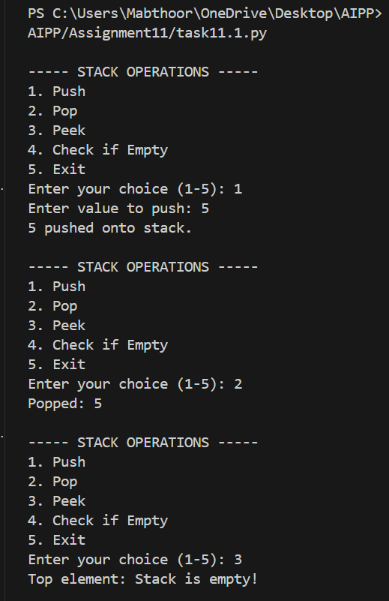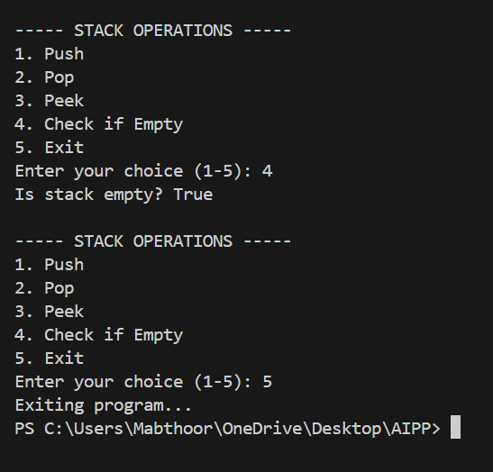

Task 2:
Use AI to generate a Queue class with enqueue(), dequeue(), and
is_empty().
CODE:
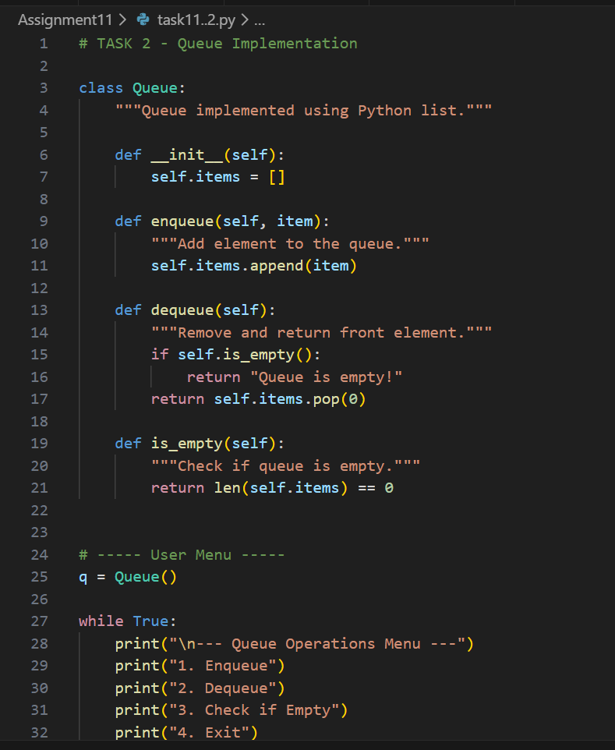
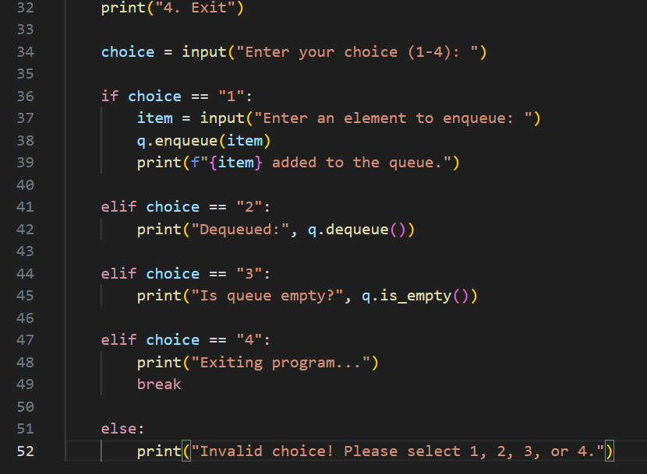

OUTPUT:
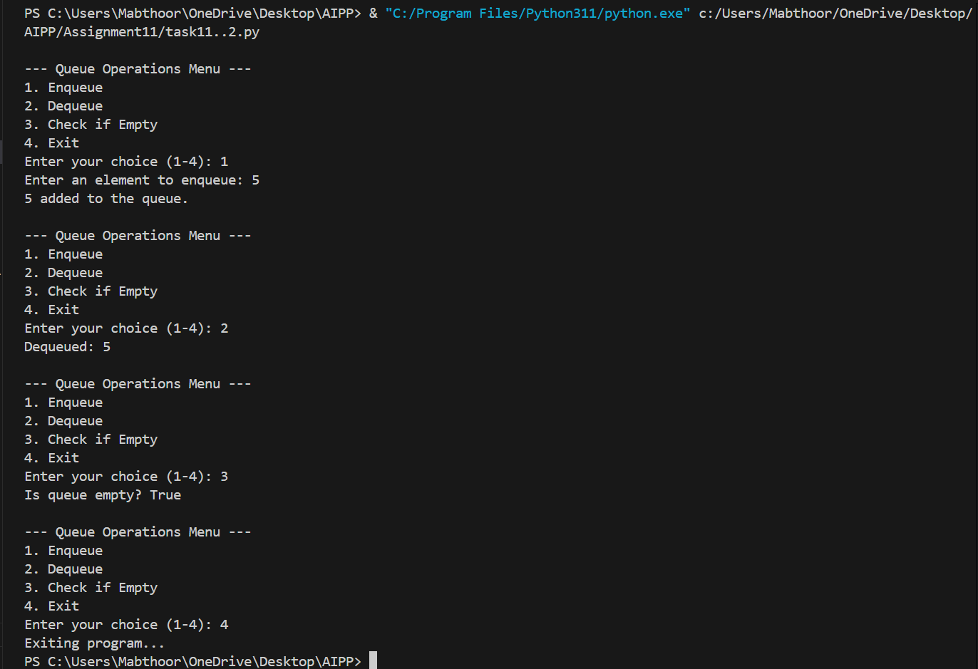

Task 3:
Ask AI to create a singly linked list with insert_at_end(),
insert_at_beginning(), and display() .
CODE:
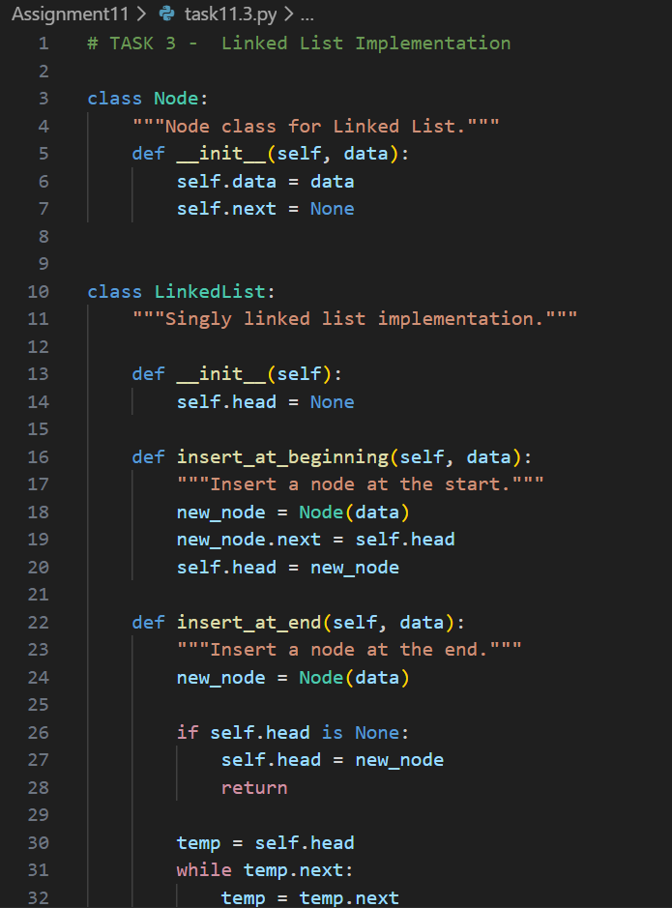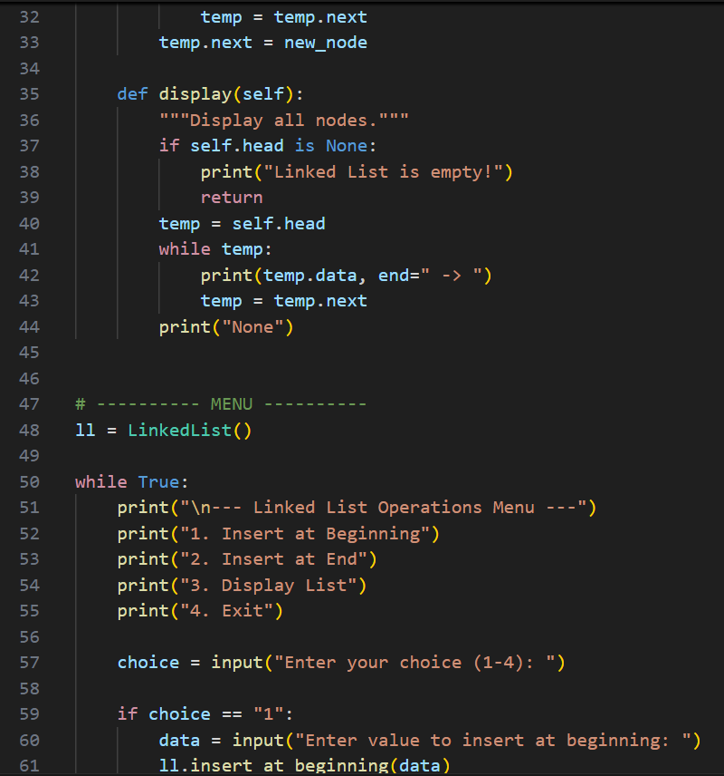
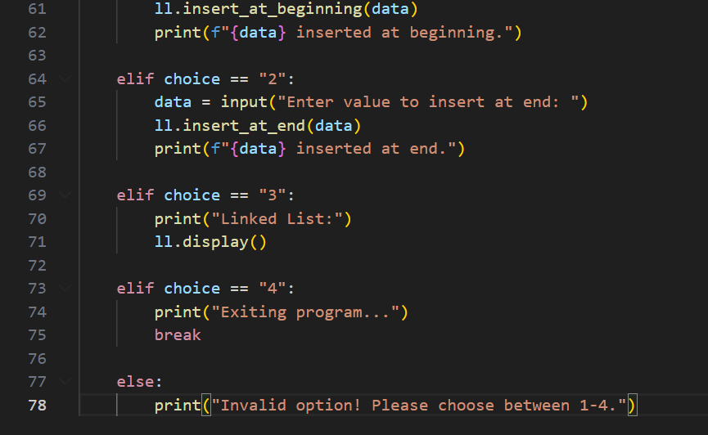
OUTPUT:
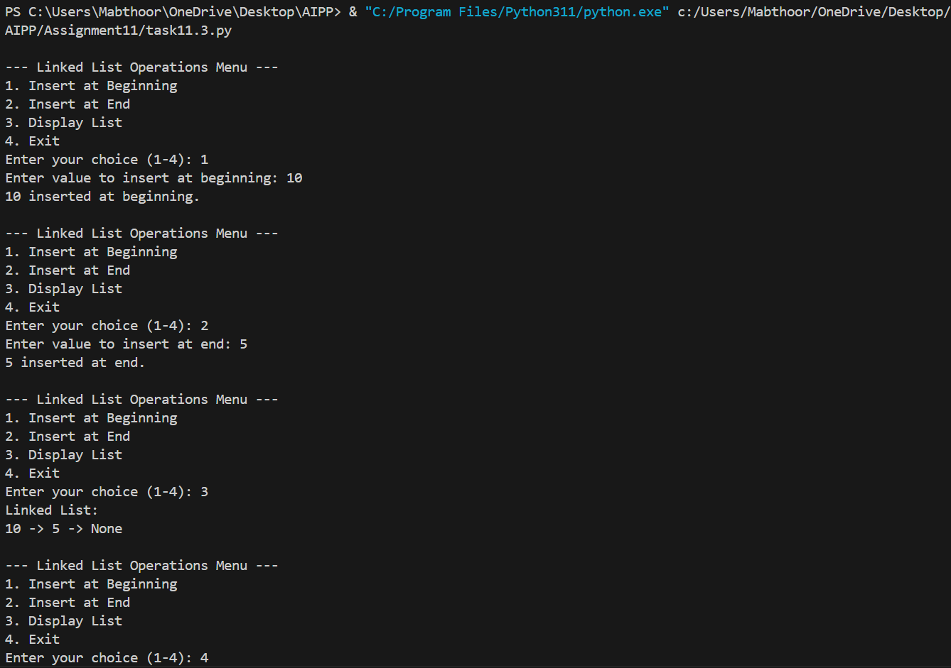

Task 4:
Ask AI to generate a simple BST with insert() and
inorder_traversal().
CODE:
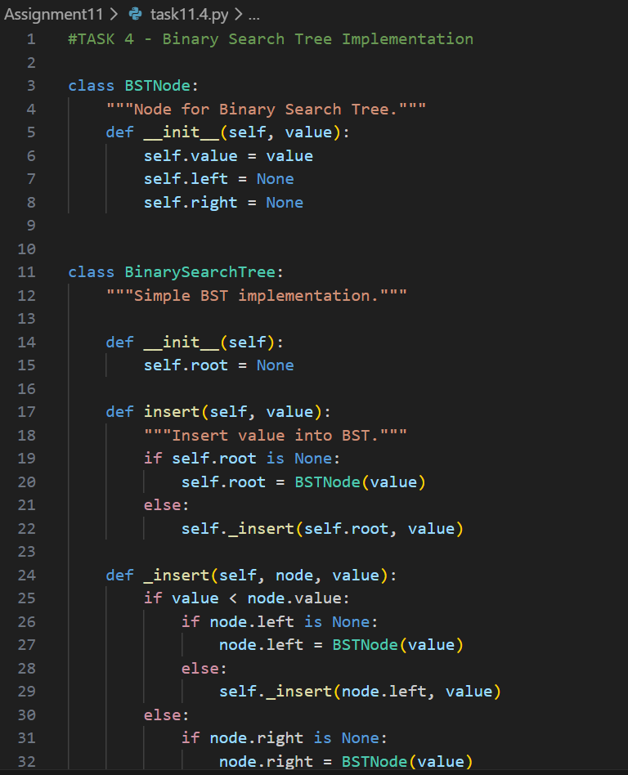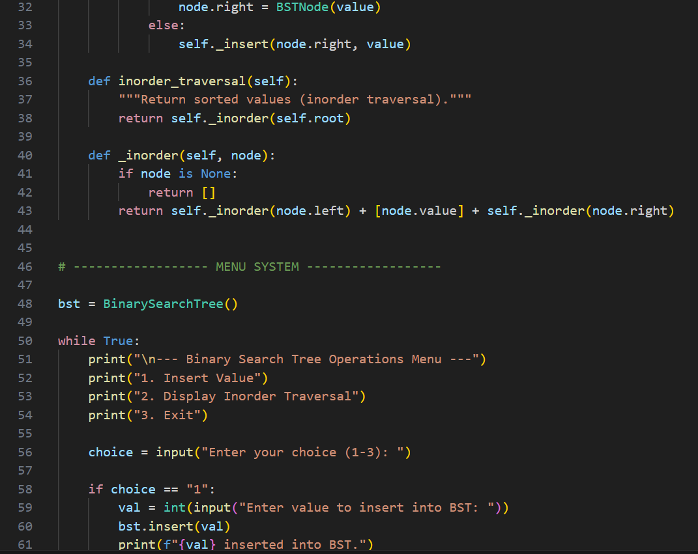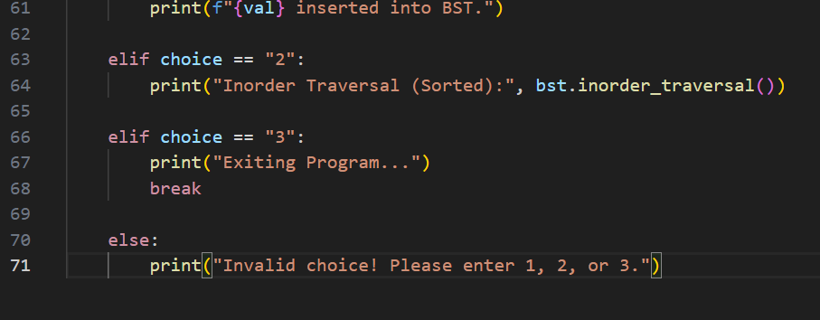

OUTPUT:




